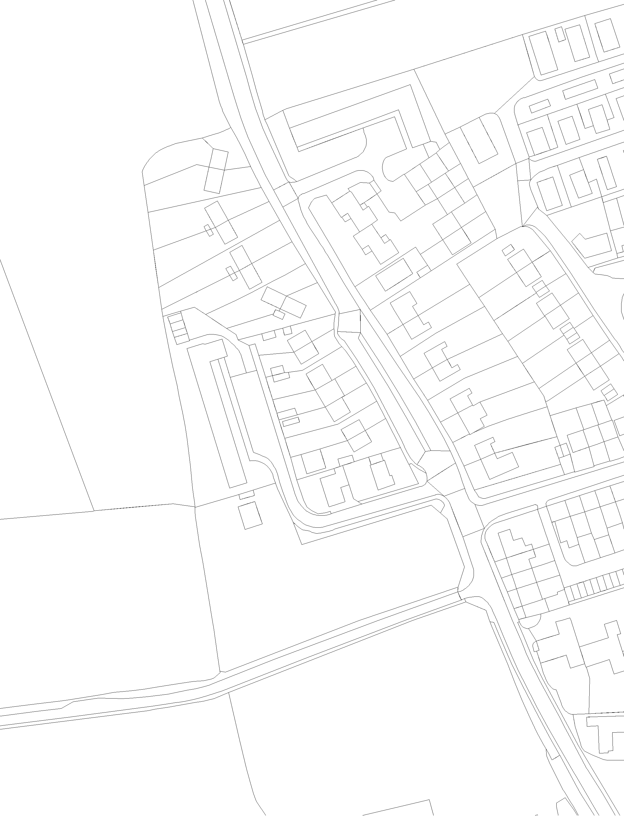
67.0m ´
Parkway
use

Cumberlege

House

67.4m

67.1m
Appendix 1: Cumberlege House, Marston
Scale: 1:1,250
© Crown Copyright and database right 2014. Regeneration & Major Projects
Ordnance Survey 100019348.

